Ujian Tengah Praktikum - Semester Ganjil 2022/2023
Practicum Mid Exam – Odd Semester Year 2022/2023
Matakuliah  Subject |  |  | COMP6799001 – Database Technology |  |  | 
Kelas  Class | : | 09BB |  | Tanggal Mulai  Start Date | : 28 July 2022
Kelas  Class | : |  |  | Waktu Mulai  Start Time | : 13:00
Dosen  Lecturer | : | D3219 - Dr. Tanty Oktavia, S.Kom., MM, CSCA, CDAP |  | Tanggal Selesai  End Date | : 28 July 2022
Dosen  Lecturer | : |  |  | Waktu Selesai  End Time | : 14:10

PERATURAN UJIAN:
Exam Regulations:
- Mahasiswa tidak diperbolehkan berdiskusi dan/atau bekerja sama dengan peserta ujian lainnya
Student is not allowed to discuss and/or work together with other exam participants
- Mahasiswa tidak diperbolehkan menyalin jawaban dari intenet
Student is not allowed to copy answer from the intenet
- Asisten BERHAK memberi nilai 0 (NOL) bagi peserta ujian yang melakukan segala bentuk kecurangan
Assistant is able to give 0 (ZERO) score for exam participant who does any cheating actions
- Kumpulkan jawaban tepat pada waktunya
Submit the answer on time
- Bila Anda tidak membaca peraturan ini, maka Anda dianggap telah membaca dan menyetujuinya
If you have missed to read these regulations, so you are considered to have read and agreed on it

SOFTWARE YANG DIGUNAKAN:
Software will be used:
- XAMPP 7.4.7

FILE YANG DIKUMPULKAN:
File must be collected:
- SQL

PERHATIAN!
Attention!
- Bagi yang mengerjakan tidak sesuai dengan soal, maka akan diberikan nilai NOL (0)
For those who do not work in accordance with the exam case will be marked as ZERO (0)
- Bagi yang mengerjakan tidak sesuai dengan software dan versi yang telah ditetapkan, maka akan tetap dikoreksi dengan software dan versi yang telah ditetapkan
For those who do not work in accordance with the software and specific version will be corrected by the predefined software and version
- Kompres semua jawaban yang akan diunggah. Pastikan format pengumpulan nama file dan ekstensi sesuai dengan format berikut: [NIM]-[NAMA].zip
Compress all file that will be uploaded. Make sure the format for collecting file name and extension according to the following format: [NIM]-[NAME].zip

Tabel Relasional
Relational Table

chatENraise

chatENraise is a famous cake shop located in Jakarta. chatENraise provides transaction for every customer who wants to buy cake and will be handled by a staff with different positions. You are asked to expand its shop by managing their database transaction. Here is the Entity Relationship Diagram (ERD) of chatENraise:

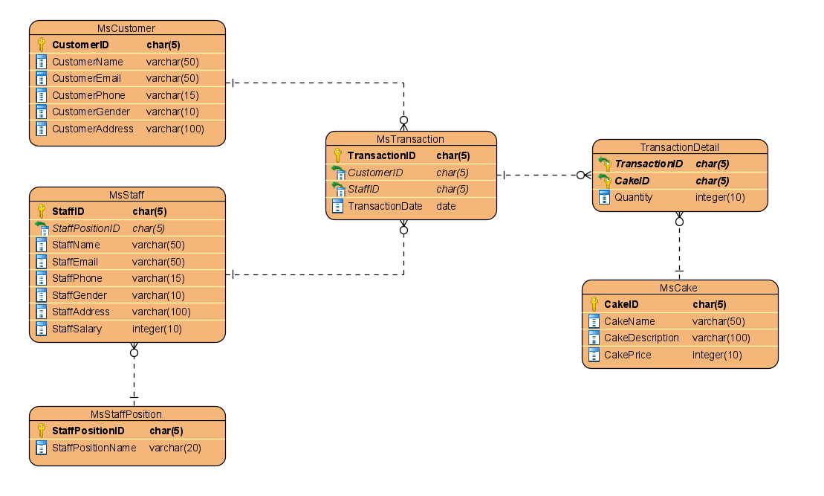

Soal
Case

Note: Import ‘chatenraise’ database before answering the questions below.

- Create a database named ‘chatenraisemember’.
(CREATE DATABASE)

- Create a table named ‘SubcriptionUser’ in ‘chatenraisemember’ database with the following description:
(CREATE TABLE, REGEXP)

Column Name | Data Types | Length | Description
SubscriptionTypeID | CHAR | 6 | Primary key and SubscriptionTypeID must be started with ‘SUB’ and followed by 3 digits of number. Cannot be empty.  Example: SUB001,
SubscriptionTypeName | VARCHAR | 100 | Cannot be empty.
DiscountPercentage | INT | - | Cannot be empty.  Must be more than 0

- Create a table named ‘SubcriptionUser’ in ‘chatenraisemember’ database with the following description:
(CREATE TABLE, REGEXP)

Column Name | Data Types | Length | Description
UserID | Char | 5 | Primary key and UserID must be started with ‘CU’ and followed by 3 digits of number.  Example: CU001,  Cannot be empty.
SubscriptionTypeID | Char | 6 | Cannot be empty.  Foreign key to table ‘SubscriptionType’ column ‘SubscriptionTypeID’ and any changes happen to a data can affect the other data (delete the other data)
StartDate | Date |  | Cannot be empty.
EndDate | Date |  | Cannot be empty

- Insert these data into SubscriptionType and SubscriptionUser table:
(INSERT)
SubscriptionType
SubscriptionTypeID | SubscriptionTypeName | DiscountPercentage
SUB001 | Epic | 2
SUB002 | Legend | 5
SUB003 | Mythic | 10

SubscriptionUser
UserID | SubscriptionTypeID | StartDate | EndDate
CU001 | SUB001 | 2022-07-10 | 2023-01-10
CU005 | SUB002 | 2022-07-15 | 2023-10-10
CU007 | SUB003 | 2022-07-20 | 2023-07-10
- From ‘chatenraise’ database, display CakeName, CakeDescription, and CakePrice for every cake which description is more than or equals 4 words.
(LIKE)
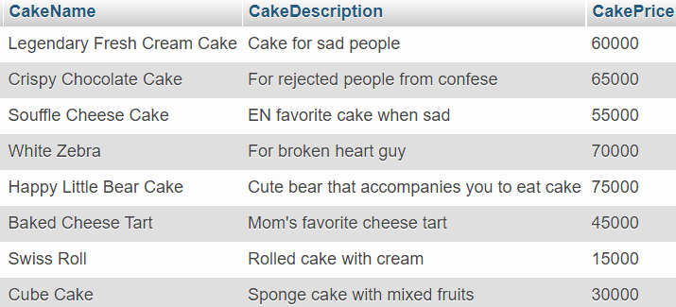

- From ‘chatenraise’ database, display CustomerName, CustomerPhone (obtained from CustomerPhone by replacing ‘08’ to ‘+62’), StaffName, StaffPositionName, TransactionMonth (obtained from name of the month TransactionDate) for every transaction whose CustomerName is more than 1 word and StaffSalary more than 2.000.000.
(DATE_FORMAT, LIKE, REPLACE)
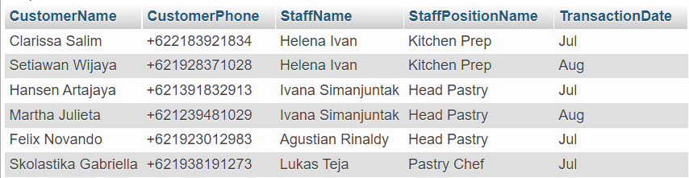

- Display CustomerName, SubcriptionTypeName, TransactionDate, StartDate, EndDate, DiscountPercentage for every transaction which customer has ‘Mythic’ and ‘Legend’ subscription type and the transaction that happens on 7th month.
Note: Subscription data are obtained from ‘chatenraisemember’ database, and Customer data are from ‘chatenraise’ database that are connected by UserID and CustomerID.
(MONTH, IN)

- From ‘chatenraise’ database, update customer name into ‘Erwin Setiawan Wijaya’ for transaction that happens 2 days after ‘2022-08-10’.
(UPDATE, DATEDIFF)
Before update:
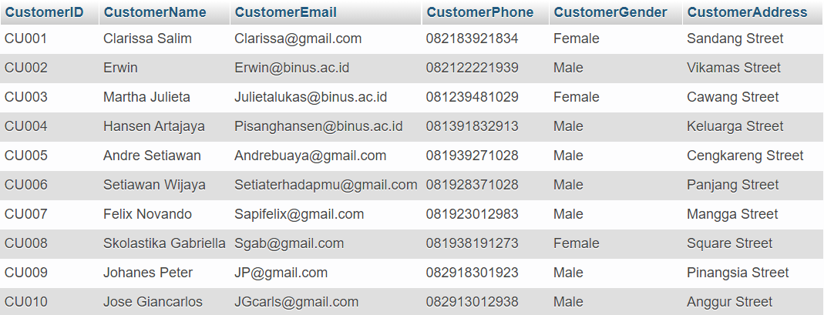

After update:
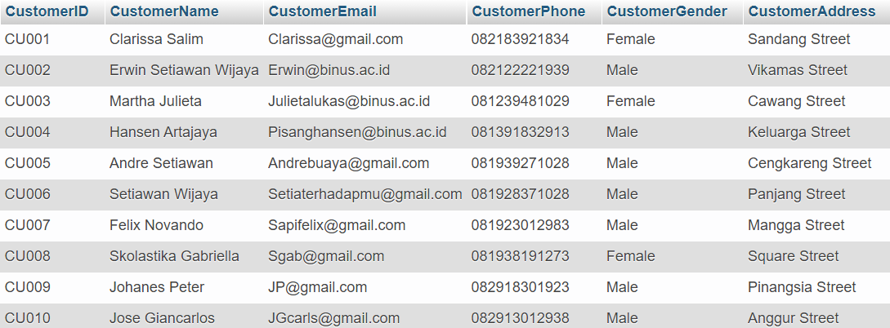

- From ‘chatenraise’ database, delete staff which handle transaction 1 month (30 days) after ‘2022-06-10’.
(DELETE, DATEDIFF)
Before delete:
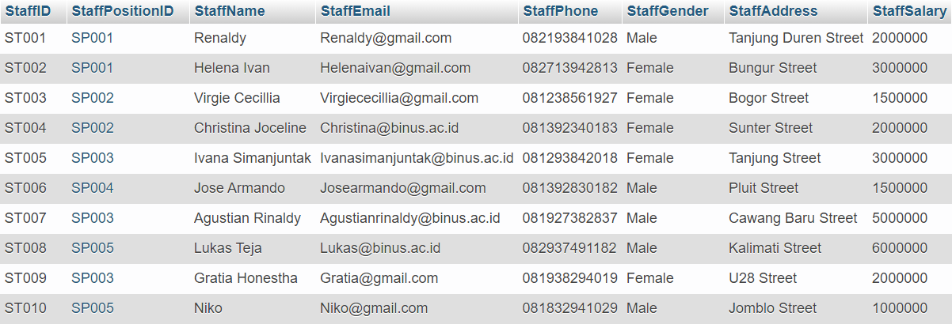

After delete:
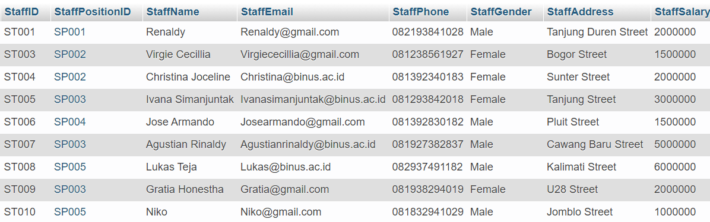

- Delete database named ‘chatenraise’.
(DROP DATABASE)

ʕっ￫ᴥ￩ʔっ Goodluck ⊂ʕ•ᴥ•⊂ʔ

